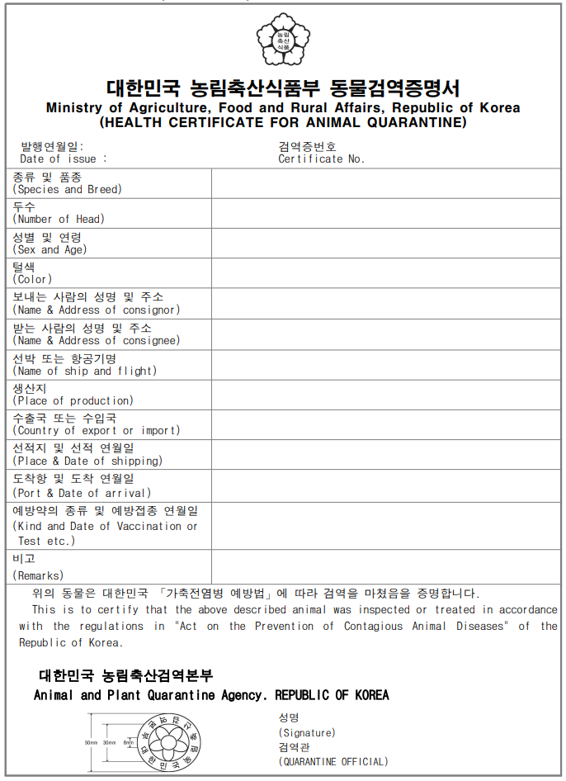


Ministry of Agriculture, Food and Rural Affairs, Republic of Korea

Additional Certification

I, the undersigned veterinary officer, hereby certify the followings with respect to the cattle identified in the Animal Health Certificate No. of .
- Republic of Korea has been free from Contagious bovine pleuropneumonia, Vesicular stomatitis, Bovine spongiform encephalopathy (BSE), and Bluetongue.
- The premises of origin locate in Republic of Korea.
3.1 Name of the premises of origin:
3.2 Address of the premises of origin:
3.3 The premises of origin of cattle is not under restriction by the central or local government due to any officially controlled infectious or contagious diseases of cattle.
- No clinical case of Brucellosis, Tuberculosis, Bovine Viral Diarrhea-Mucosal Disease (BVD- MD), Infectious Bovine Rhinotracheitis (IBR), FMD, Johne's disease, Enzootic bovine leucosis and Ibaraki Disease have been reported in the cattle originated farm to export for the past twelve (12) months prior to and till the date of export.

- The cattle for export were kept isolated in the embarkation-quarantine facilities approved by the Korean animal health authorities as a secured and guaranteed place from an animal health point of view for at least 7 days.

  - Name and address of the embarkation-quarantine facilities:

  - Period of Quarantine: YY/MM/DD ~ YY/MM/DD

- The cattle for export did not show the evidence of any infectious diseases through the careful clinical inspections conducted by the Korean Animal Health authorities during the embarkation-quarantine.
- The cattle for export were tested for the following diseases in a laboratory approved by the Korean Animal Health authorities with negative results and all the tests have been conducted within 60 days prior to embarkation.
  - Brucellosis using Rose-Bengal test (serum agglutination test)
Date of test: YY/MM/DD ~ YY/MM/DD
Name of Official Laboratory:
  - Tuberculosis using the Tuberculin intradermal reaction test
Date of test: YY/MM/DD ~ YY/MM/DD
Name of Official Laboratory:

- The exported cattle were treated for external parasites with an approved insecticide by an approved method by the Korean animal health authorities within 7 days prior to the shipment to Nepal and are found free from external parasites at the time of shipment.
  - Name of medicine:
  - Treatment Method:
  - Date of treatment:
- The exported cattle were vaccinated in accordance with the following program.

ID No. of Animal | Disease | Type of Vaccine | Date of Vaccination
- All the containers, vehicles and loading places of the ship or aircraft to be used for transportation of the exported cattle were cleaned up in advance of loading and be thoroughly disinfected with disinfectants approved by the Korean animal health authorities and under the supervision of the Korean animal health authorities.
- The exported cattle have been kept isolated from any other cloven-hoofed animals during the transportation period in Republic of Korea. No cloven-hoofed animals are mixloaded with the exported cattle at the time of shipment for export.
- Feed and bedding to be used during the transportation period of the exported cattle to Nepal were provided from the same source used for the embarkation-quarantine.
- The breeding bull to be exported should have never been used for natural service.

Printed Name and Signature

Veterinary Quarantine Officer Date of Issue
(Official Stamp)
Place of Issue
Regional Office
Animal and Plant Quarantine Agency
Ministry of Agriculture, Food and Rural Affairs,
Republic of Korea

[Appendix]
Identification of the cattle

ID No | Date of Birth | Sex | Breed | Name and Address of  Farm of Origin | Remark

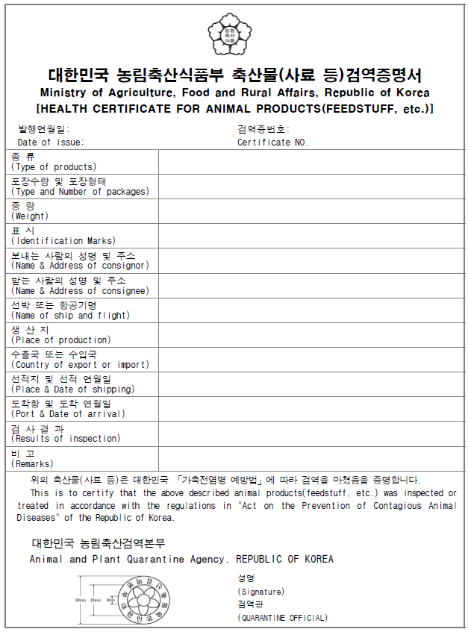

Ministry of Agriculture, Food and Rural Affairs, Republic of Korea

Additional Certification

I, the undersigned veterinary officer, hereby certify the followings with respect to the bovine semen identified in the Animal Health Certificate No. of
.

- Korea has been free from bluetongue, contagious bovine pleuropneumonia and Artificial Insemination Centre(zone) has been free from foot and mouth disease, brucellosis and tuberculosis for the past twelve(12) months prior to and till the date to export.

- The semen is derived from an artificial insemination centre which is under supervision of a veterinary surgeon and is approved / licensed by the Government of the Korea.

- The semen is derived from animals which had been kept in the Artificial Insemination Centre from at least six(6) months prior to the date of collection.

- No clinical case of contagious bovine pleuropneumonia, infectious bovine rhinotracheitis, leptospirosis, campylobacteriosis, bovine viral diarrhea and Ibaraki Disease have been reported in the Artificial Insemination Centre for the past twelve(12) months prior to and till the date of export.

- The donor were subjected to the following test with negative results within 12 months prior to last collection :
  - Tuberculosis : tuberculin test or Gamma interferon test
  - Infectious bovine rhinotracheitis : PCR test (Semen or Blood)

  - Brucellosis : Rose Bengal Test or ELISA
  - Leptospirosis : Microscopic agglutination test (MAT)
  - Campylobacter fetus subsp. venerealis and Trichomonas foetus : preputial culture
  - Bovine viral diarrhea-mucosal disease(BVD-MD) : Antigen ELISA
  - Enzootic bovine leukosis : ELISA

- The donor has not shown clinical sign of any infectious and contagious disease on the day of semen collection and for the following 21 days.

- All semen in the consignment was collected, processed, identified, stored and transported under the direct supervision and control of an AI center veterinary surgeon.

- All equipment used for collection, dilution, packaging of semen is either new or has been cleansed and disinfected before use in a hygienic manner and the the semen has been kept in a clean and disinfected container with fresh new liquid nitrogen.

- The teaser animal to be exported should have never been used for natural service.

Printed Name and Signature Veterinary Quarantine Officer
Date of Issue

(Official Stamp) Place of Issue

Regional Office Animal and Plant Quarantine Agency
Ministry of Agriculture, Food and Rural Affairs, Republic of Korea

