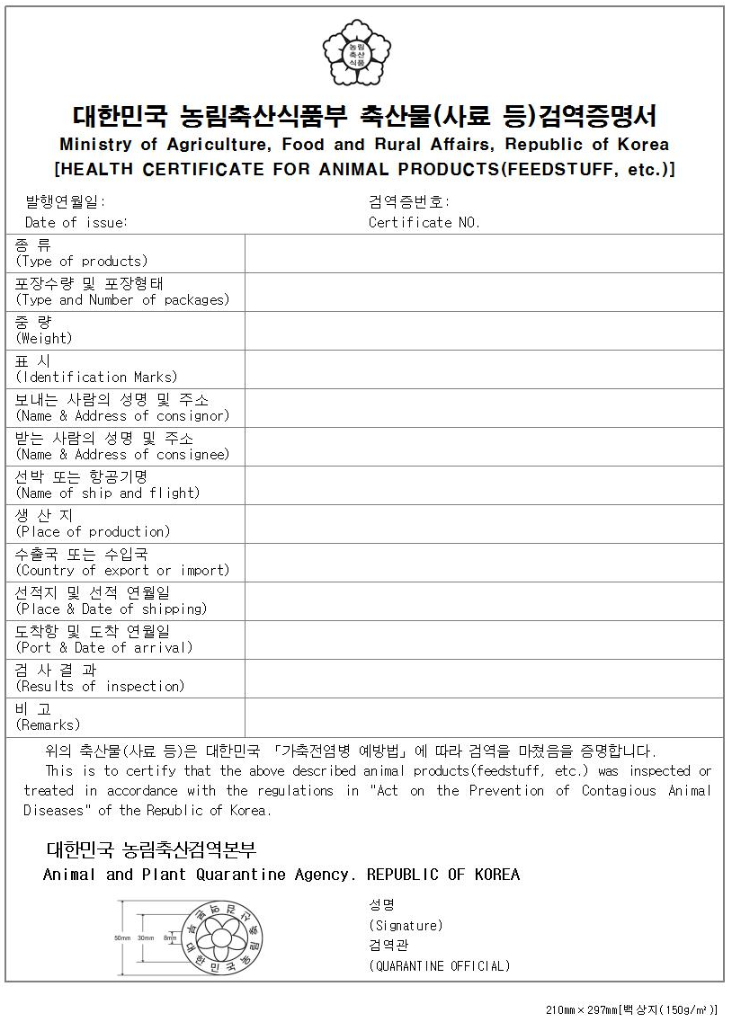

Ministry of Agriculture, Food and Rural Affairs, Republic of Korea

I, the undersigned veterinary officer, hereby certify the followings with respect to the bovine semen identified in the Animal Health Certificate No. of _________________.

1. The semen has been collected, stored and transported in accordance with the OIE Terrestrial Animal Health Code.

2. The Republic of Korea is free from rinderpest, bluetongue, bovine spongiform encephalopathy(BSE), and lumpy skin disease.

3. The artificial insemination(AI) center from which semen originated has been free from brucellosis, contagious bovine pleuropneumonia, foot and mouth disease (vaccination is practiced), and bovine tuberculosis during the 6 months prior to the first collection and until 30 days after the last collection of the semen.

3.1. The artificial insemination(AI) center is not under restriction by the central or local government due to any officially controlled infectious or contagious diseases of cattle.

4. The semen is collected from donor bull(s) found free from clinical symptoms of any contagious, congenital, venereal, endemic disease.

4.1. Donor bull(s) have been free from bovine leucosis, east coast fever(theileriosis), heartwater disease, leptospirosis, malignant catarrhal fever, paratuberculosis, rift valley fever, bovine viral diarrhea.

4.2. Donor bull(s) were never used for natural service/mating.

5. The semen donor bulls have been tested for the following diseases in a laboratory approved by the Korean Animal Health authorities with negative results and all the tests have been conducted within 6 months prior to semen collection.

5.1. Bovine brucellosis using Rose-Bengal test
Date of test: YY/MM/DD ~ YY/MM/DD
Name of Official Laboratory:

5.2. Bovine tuberculosis using the tuberculin intradermal reaction test
Date of test: YY/MM/DD ~ YY/MM/DD
Name of Official Laboratory:

5.3. Bovine genital campylobacteriosis and trichomonas using culture test
Date of test: YY/MM/DD ~ YY/MM/DD
Name of Official Laboratory:

5.4. IBR-IPV using ELISA or PCR test
Date of test: YY/MM/DD ~ YY/MM/DD
Name of Official Laboratory:

5.5. Leptospirosis using microscopic agglutination test(MAT)
Date of test: YY/MM/DD ~ YY/MM/DD
Name of Official Laboratory:
or
Long acting oxytetracycline treatment twice at a 14 day interval
Date of treatment: YY/MM/DD and YY/MM/DD

5.6. Bovine leucosis using ELISA test
Date of test: YY/MM/DD ~ YY/MM/DD
Name of Official Laboratory:

5.7. Johne's disease using ELISA test
Date of test: YY/MM/DD ~ YY/MM/DD
Name of Official Laboratory:

6. All equipment used for collection, dilution, packaging of semen is whether new or has been cleansed and disinfected before use. And the semen has been kept in a clean and disinfected container with fresh new liquid nitrogen.

Printed Name and Signature  Veterinary Quarantine Officer  (Official Stamp) |  | Date of Issue
 |  | Place of Issue
Regional Office
Animal and Plant Quarantine Agency
Ministry of Agriculture, Food and Rural Affairs,
Republic of Korea

